**CCT College Dublin**

**Assessment Cover Page**

|  |  |
| --- | --- |
| **Module Title:** | *Hdip DA for Business* |
| **Assessment Title:** | Integrated Machine Learning for Bussiness and Data Visualization CA2 |
| **Lecturer Name:** | James Garza/Sam Weiss |
| **Student Full Name:** | Priya Arvind |
| **Student Number:** | sbs23062 |
| **Assessment Due Date:** | 26 November 2023, 11:59 PM |
| **Date of Submission:** | November 26th |

**Declaration**

|  |
| --- |
| By submitting this assessment, I confirm that I have read the CCT policy on Academic Misconduct and understand the implications of submitting work that is not my own or does not appropriately reference material taken from a third party or other source. I declare it to be my own work and that all material from third parties has been appropriately referenced. I further confirm that this work has not previously been submitted for assessment by myself or someone else in CCT College Dublin or any other higher education institution. |

**Content (has to be changed)**

References 24

**Introduction**

Our project focused on the application of Time series analysis using machine learning modelling. application of Text Analytics using machine learning modelling and predicit the real-world data set - REDDIT social media posts and analysis and Predict the sentiments.

Design and create an interactive dashboard using your chosen dataset Ireland new property housing prices dataset from data.gov.ie.our report covers the different stages of the project, including data understanding, data preparation, data visualisation and machine learning implementation and evaluation.  
Overall, this project allowed us to apply our skills in data visualisation and machine learning to a real-world problem

1. **Objectives**

In the below Project, We discussed the concept and application of Time series analysis using machine learning modelling on monthly Australian beer production for the year 1996. The purpose of the Augmented Dickey-Fuller test in time series. using Box-Jenkins model-SARIMA forecasts the last 10 observations.

( <https://www.kaggle.com/sergiomora823/monthly-beer-production>)

Apply Text Analytics on the real-world data set - 30 Top Social Media REDDIT posts on Job topics using machine learning modelling and categories and predict the sentiments of the Social Media Post.

Design and create an interactive dashboard using real-time dataset Ireland's new property housing prices dataset from data.gov.ie

<https://data.gov.ie/dataset/annual-new-property-prices/resource/a169d257-3167-4a52-9c6a-c01344e8dc2d>

We have set a few objectives for this assignment:

* Application of Time series analysis on the dataset.
* Augmented Dickey-Fuller test to check the stationary and trend of the dataset.
* Application of Jenkins model-SARIMA to the Monthly beer production dataset.Checked for the model adequacy.
* Forecasts the last 10 observations.
* Determined the forecast errors, and made a time series plot of the data.
* Illustrated the sample autocorrelation and partial autocorrelation (PA)
* Collect 30 Top Social Media posts -REDDIT posts on Jobs Topic using API’s.
* Apply Text Analytics on the real-world data set - REDDIT social media posts using machine learning modelling.
* Categories and predict the sentiments of the Social Media Posts.
* Creating a Machine Learning predictive model on 'contract status' based on the available dataset.
* Design dashboard using real-time dataset Ireland's new property housing prices dataset from data.gov.ie
* Create a wireframe proposing the design of the dashboard before implementation.
* Create an interactive dashboard -include at least three rows and two columns for a total of six sections.
* The dashboard will be designed to be interactive, allowing the audience to filter and explore the data in more detail

## **Part1: Forecasted monthly Australian beer production for the year 1996 using Time Series**

Application of Time series analysis using machine learning modelling on monthly Australian beer production for the year 1996. The purpose of the Augmented Dickey-Fuller test in time series. using Box-Jenkins model-SARIMA forecasts the last 10 observations.

* **About the Dataset Dimensions:**

The dataset contains 2 features ‘Month’ -DateTime type and ‘Monthly beer production’

With a total of 476 rows.

* **Source**

( <https://www.kaggle.com/sergiomora823/monthly-beer-production>)

* **Technologies used:-**

During the assignment execution, we were using multiple libraries. Some of them are: pandas, numpy, seaborn, matplotlib, statsmodels,sklearn.metrics .

* **Data Preparation**
  1. Converted Month Column to datetime format.
  2. Renamed "Monthly beer production” column name to “Beer_Production”.

The goal of this exercise is to predict Australian beer production for the year 1996. The data supplied consists of only one (endogenous) variable. This makes it an autoregressive problem, so we have to tackle it with the proper Model.



* **Data Understanding**
  + Converted Month Column to datetime format.
  + Renamed "Monthly beer production” column name to “Beer_Production”.
  + When we look closely into our data,we can clearly see that there is some annual seasonality[¶](https://www.kaggle.com/code/mohammedakhil/sarima-model-on-beer-production-forecast#When-we-look-closely-into-our-data,we-can-clearly-see-that-there-is-some-annual-seasonality).
  + Several features are obvious. 1) the time series is not stationary (Augmented Dickey-Fuller test used later).
* Overall Observations- there has been a regime change from upward trending to lightly downward trending.
* The volatility seem to increase in time (we could analyse the changes or residuals after fitting the trendline).

All of these observations can be tested, but by no means alone bring us closer to making the best possible OOS prediction for 1996. I have been speculating with multiple methods of countering this problem, such as transforming the timeseries to start with.

* Running adfuller on the beer production column returns the following values in order : (ADF Test Statistic, p-value, No. of Lags Used, No. of Observations Used,{Critical Values},icbest).The adfuller test returned a p-value of 0.178. We can assume that the data is stationary only if the p-value is very low (less than 0.05).
* We could perform some transformation, differencing, smoothing, outlier deletion, or removal of old data. The choice for a seasonality period in this type of problem is straightforward and we set it as 12 - the number of months in one period (year).
* To achieve stationarity, we differeced the production data by twelve months and checked the p-value using the adfuller test.
* As suspected, some annual seasonality is present since the p-value has reduced below 0.05 for 12 12-month difference. Hence we can assume stationarity when differencing by 12 months.





* For an AR model, the theoretical PACF “shuts off” past the order(p) of the model
* For an MA model, the theoretical PACF does not shut off, but instead tapers toward 0 in some manner. A clearer pattern for an MA model is in the ACF. The ACF will have non-zero autocorrelations only at lags involved in the model.

**Modelling:-**

SARIMA as the model of choice, since it allows for seasonality and trend modelling.  
  
Analysis of ACF or PCF, which dont provide definitive parameters for SARIMA, only a guidance to start a parameter grid search.

The choice for seasonality period in this type of problem is straightfoward and we set is as 12 - the number of months in one period (year).

* SARIMA combining autoregressive integrated moving average model with the same for seasonality gives us the best chances.
* Since our data is not an ideal case of the ARIMA model, the trend is not clearly visible. We will take p,d,q values as (1,1,1) and seasonal factor as 12 (for SARIMA model)



* **Forcasting**

These predictions underestimate the real-life performance of the model since as new data arrives we have the ability to spot any new trend or extreme changes and retrain/adjust our modelling strategy.  


**Evaluation**

From visual analysis, we can see that the SARIMA model performed reasonably well. However, to understand the accuracy of the model mathematically, we can calculate the residual and find the mean absolute per cent error and root mean squared error.

Also, the Model shows an Overfitted Accuracy Score.



**Conclusion**

* We do not know the unit of production so it is hard to make any concrete remarks on it from the baseline metrics
* However, from the plots, it appears that there was no big change in the production of beer in 1996 and it is very similar to the previous years
* Maybe there are other parameters that influence the beer production (e.g. temperature, humidity etc.) - which are not considered here.

**Part 2: Text Analytics on the real-world data set - 30 Top Social Media REDDIT posts on Job topics.**

Apply Text Analytics on the real-world data set - 30 Top Social Media REDDIT posts on Job topics using machine learning modelling and categories and predict the sentiments of the Social Media Post.

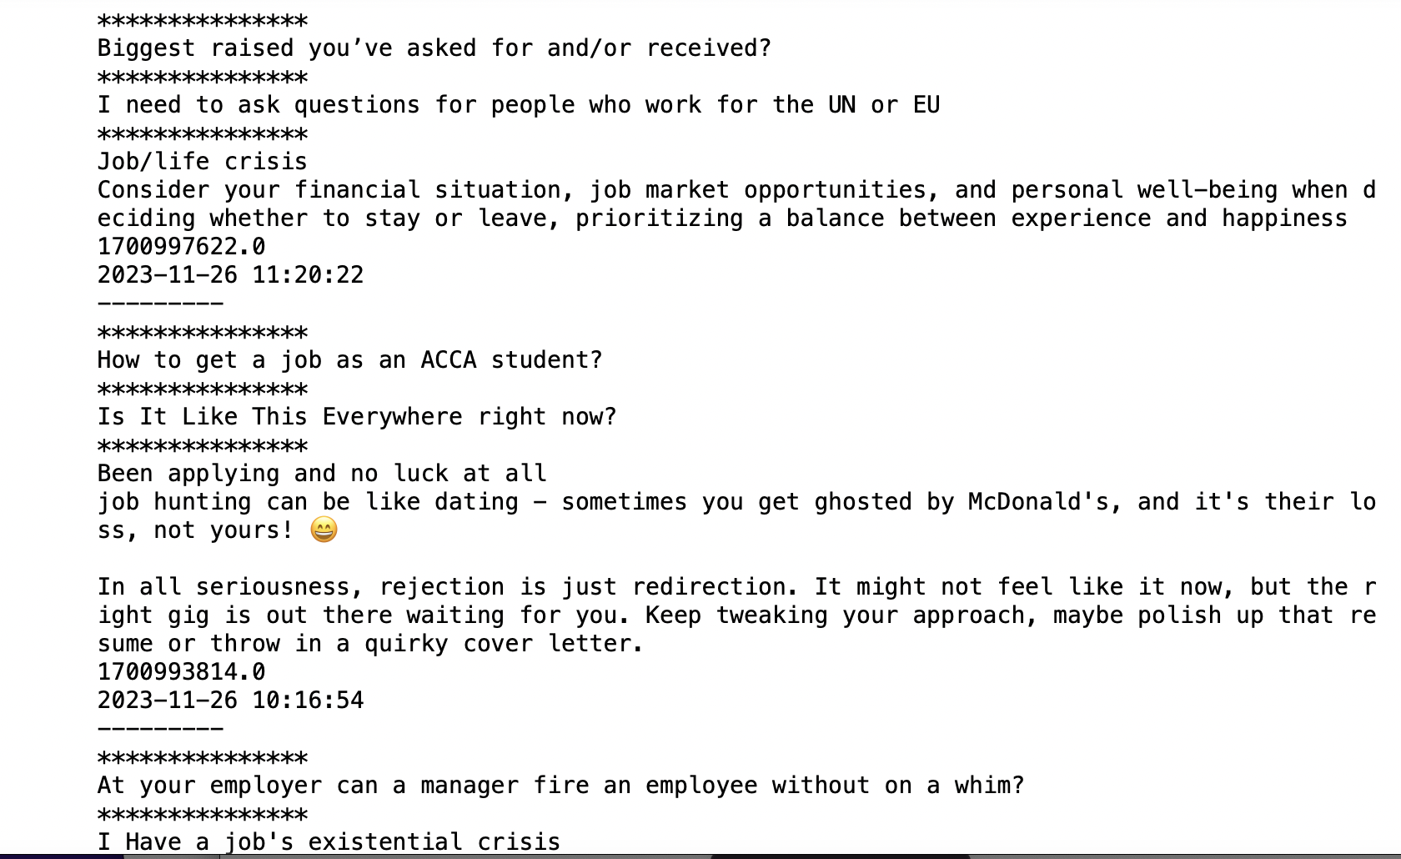

* + **Source**-We downloaded the Top 30 Social Media Posts from the Reddit website using API from PRAW Library.
  + Segregated the Posts into a dataframe with Posts body in ‘Posts Title’ column and ‘Post time ‘ column as Post timestamp.
  + When we look closely into our data, we can clearly see that there are few Punction marks and frequent unuseful words for our analysis.
  + Using word_tokenize, RegexpTokenizer and nltk libraries we tried to feature extraction with key works from Positive posts.
  + We removed all Stop words including the most frequent word from the word cloud like guys, Pre, good, need, and help.
  + We segregated the words into SentimentIntensityAnalyzer with a compound_score threshold of 0.1.



* + Any word having a compound score less than 0.1 is classified as a negative word and equal to 0.1 compound as a neutral word and a greater score is classified as a Positive word.
  + With Every new feed of posts neutral words are maximum as compared to Post and negative word.
  + The MultinomialNB model is fitting on posts and tries to predict the sentiments of the Posts.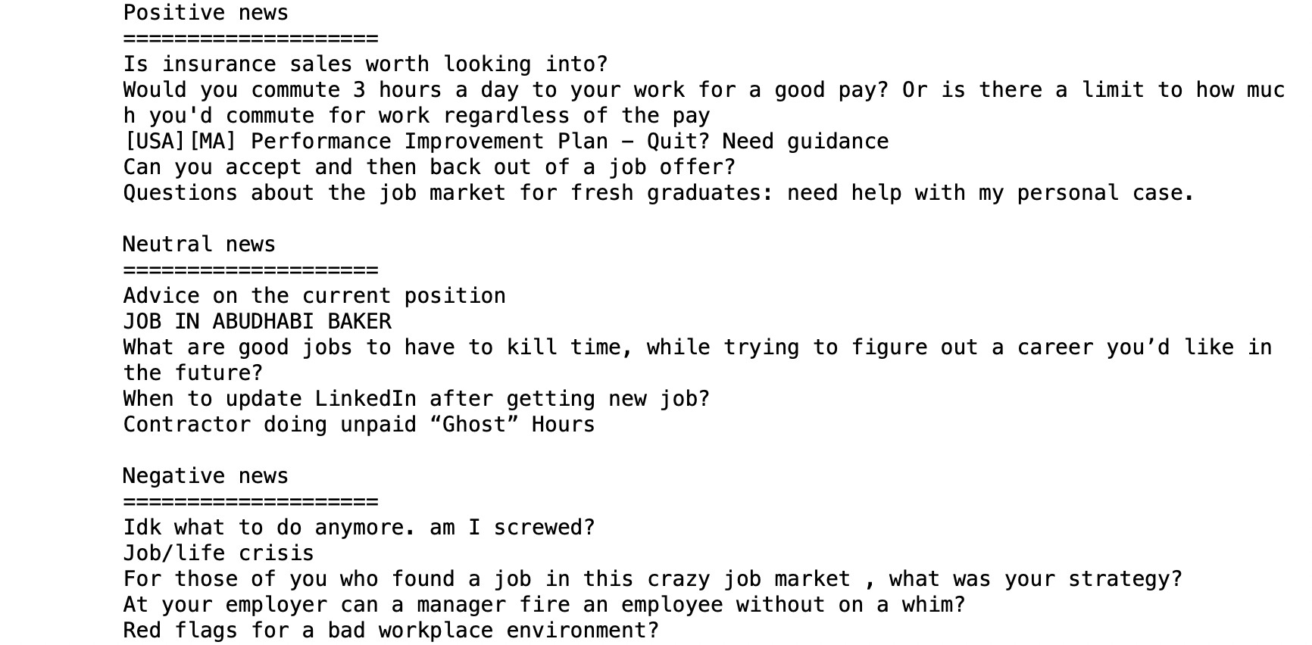

**Conclusion**

* Overall we did a good understanding of Text Analysis able to categorise the sentences as positive posts or not.
* Also, we are able to extract particular posts positive/Negative with keywords.
* We are able to predict any word into positive sentiments using the MultinomialNB Machine learning Model.

**Part 3:**

**Data Visualization -Interactive Dashboard¶**

<https://data.gov.ie/dataset/annual-new-property-prices/resource/a169d257-3167-4a52-9c6a-c01344e8dc2d>

dataset: URL: <https://opendata.housing.gov.ie/dataset/bf577a62-ac29-4d02-b7f2-b450f7b6cb60/resource/a169d257-3167-4a52-9c6a-c01344e8dc2d/download/form_41a-price-new-property-area-by_year_2.csv>

Prior to 1974 the data was based on surveys of existing house sales in Dublin carried out by the Valuation Office on behalf of the D. O. E. Since 1974 the data has been based on information supplied by all lending agencies on the average price of mortgage financed existing house transactions. Average house prices are derived from data supplied by the mortgage lending agencies on loans approved by them rather than loans paid. In comparing house prices figures from one period to another, account should be taken of the fact that changes in the mix of houses (incl apartments) will affect the average figures. Data for 1969/1970 is not available for Cork, Limerick, Galway, Waterford and Other areas The most current data is published on these sheets

**Data understanding:**

* Since Data was based on the surveys collected, Data preparation is a major task to convert Raw data to a data frame.
* There were 93 Rows with 13 Columns and many Clums are unnamed header.
* All NAN values / missing values were removed from the analysis since our goal is to Create a dashboard which will briefly describe the dataset, its provenance and domain, and a summary of the key insights derived from the exploratory data analysis.

**Data Preparation:**

* We removed all the headers and derived column names from First Row which had all the valid column names like Location name, House property price etc.
* All were removed and renamed a few Column which has white space in the Column name, which was creating issues while processing the data.
* We removed ‘,’ from the Numerical value and converted it to the respective Datatype like int for Years and floats from Housing Prices.
* All NAN values / missing values and unnamed Columns were removed from the analysis.
* Converted all Location Columns like Dublin, Cork etc under one new Column called Locations using Pandas Melt functions.

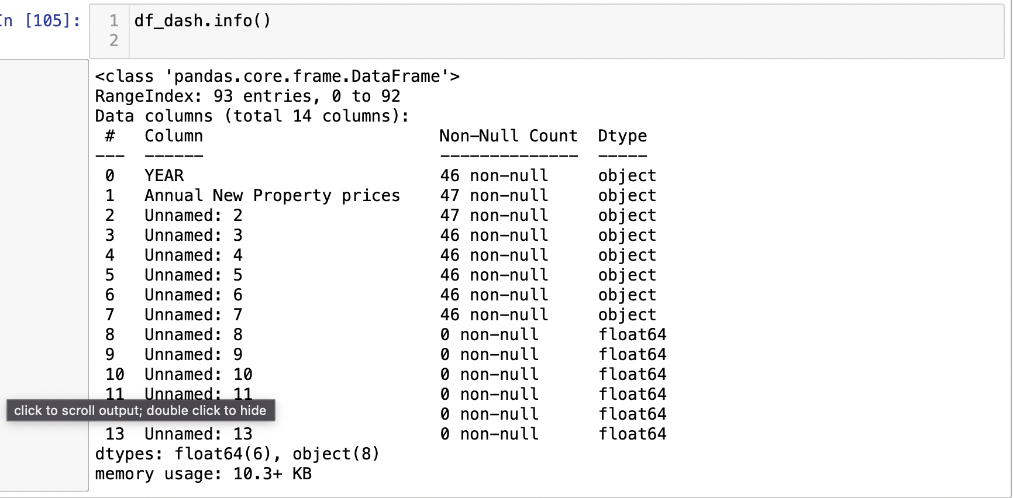

**Dashboard Wireframe**

* Since, our goal is to Create a dashboard which will briefly describe the dataset, its provenance and domain, and a summary of the key insights derived from the exploratory data analysis.
* Our focus was on 3 Features ‘Years’,’ Location’ and ‘Housing Price’.
* Panel -1st Row with 2 Columns will Showcase overall Housing Prices for each Location with respect to years. we used an Interactive Scatter Plot with a year’s value that can be selected from the scroll bar and a static Box plot will showcase any outliers in the Housing Values.
* Panel -2nd Row with 2 Columns will Showcase Housing Prices for each Location and Housing property value fluctuations over the decade or years for better comparison. we used an Interactive Line Plot with Locations that can be selected from the dropdown and static bar graph Housing property value fluctuations over the decade.
* Panel -3rdRow with 2 Columns will Showcase Particular features that can be compared with each other. we used an Interactive Scatter Plot with any 2 features and a static plot will showcase the Top 3 Housing Property price locations per decade.

**Dashboard Plots :**

* Panel -1st Row with 2 Columns will Showcase overall Housing Prices for each Location with respect to years. we used an Interactive 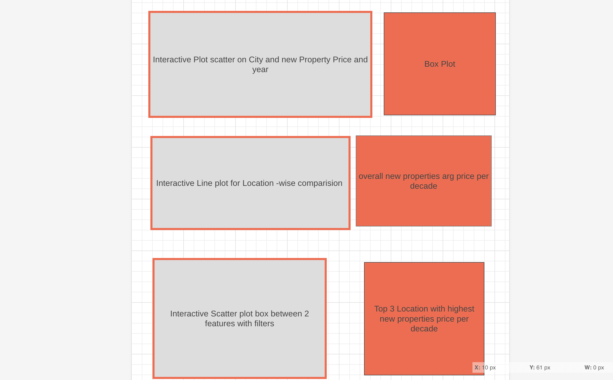Scatter Plot with a year’s value that can be selected from the scroll bar and a static Box plot will showcase any outliers in the Housing Values.

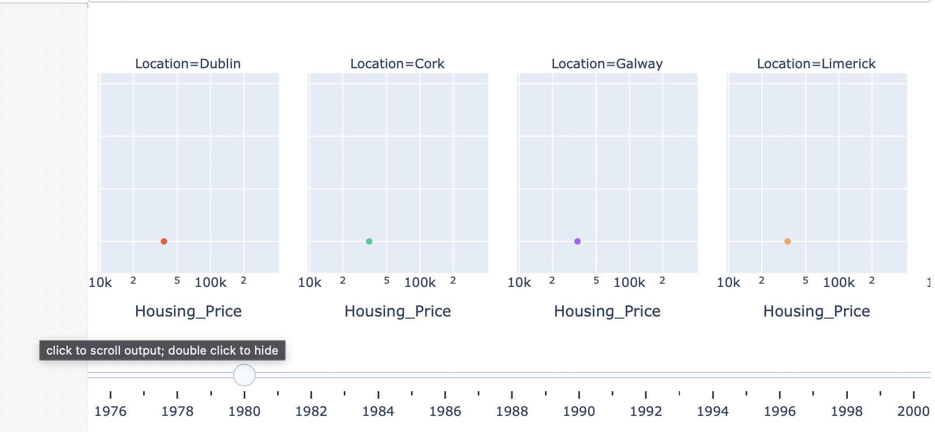

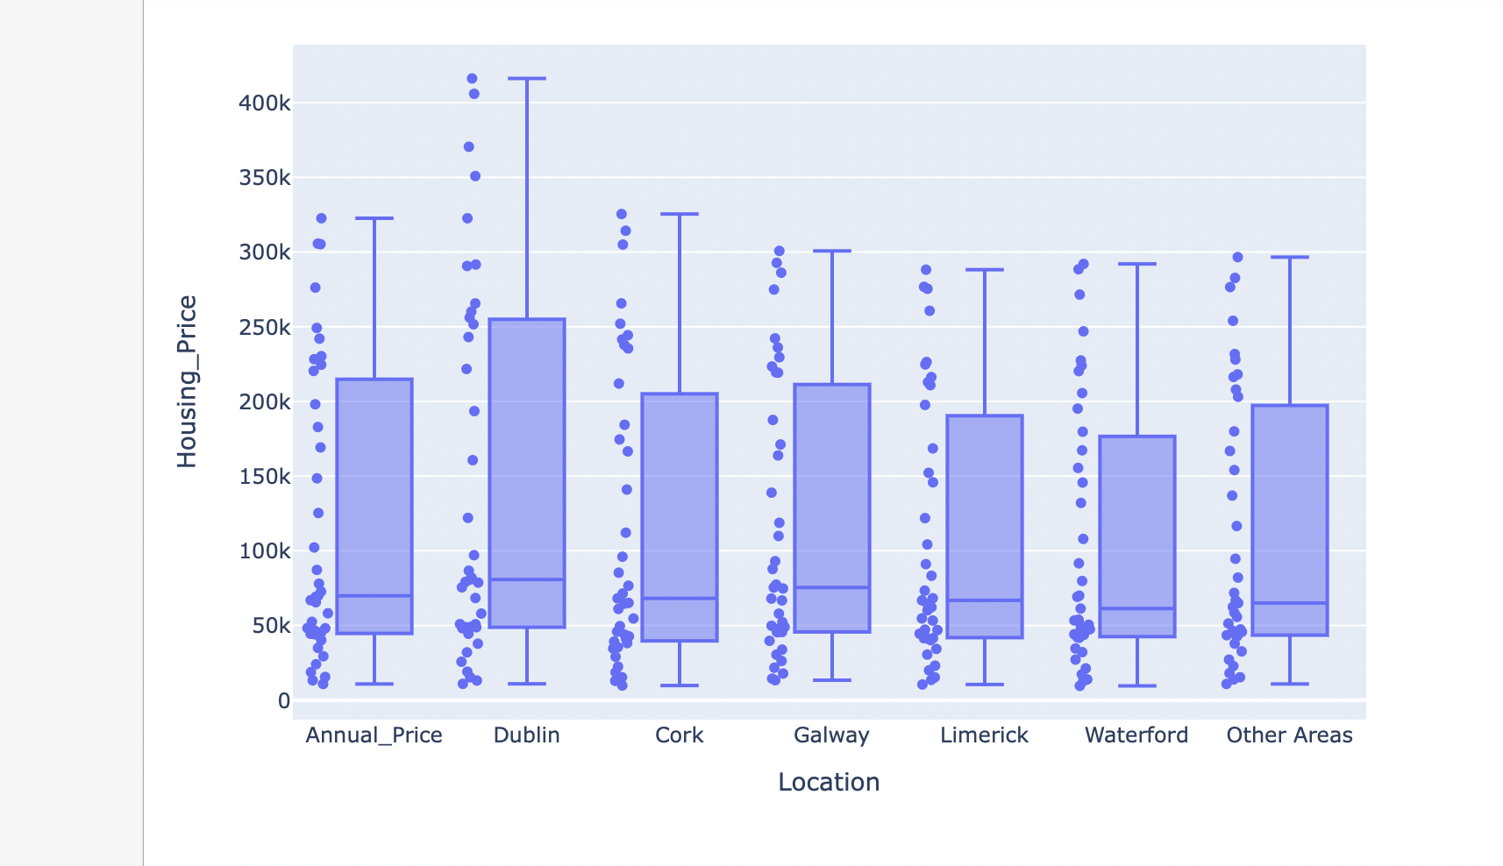

* Panel -2nd Row with 2 Columns will Showcase Housing Prices for each Location and Housing property value fluctuations over the decade or years for better comparison. we used an Interactive Line Plot with Locations that can be selected from the dropdown and static bar graph Housing property value fluctuations over the decade.

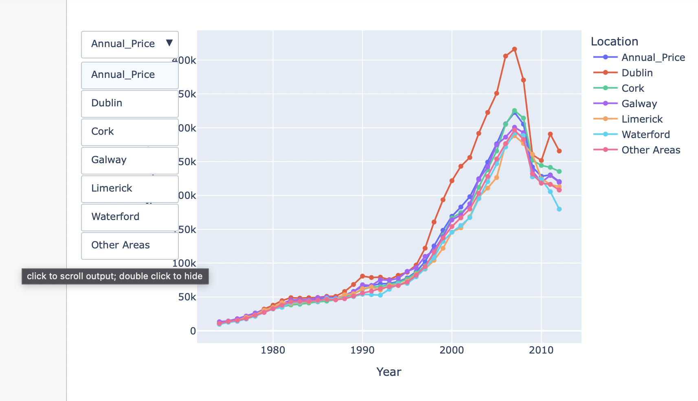

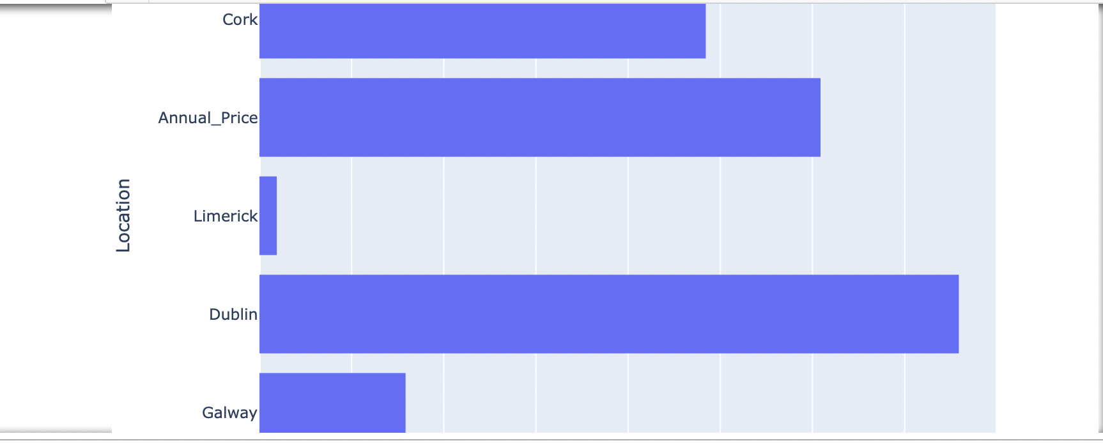

* Panel -3rdRow with 2 Columns will Showcase Particular features that can be compared with each other. we used an Interactive Scatter Plot with any 2 features and a static plot will showcase the Top 3 Housing Property price locations per decade.

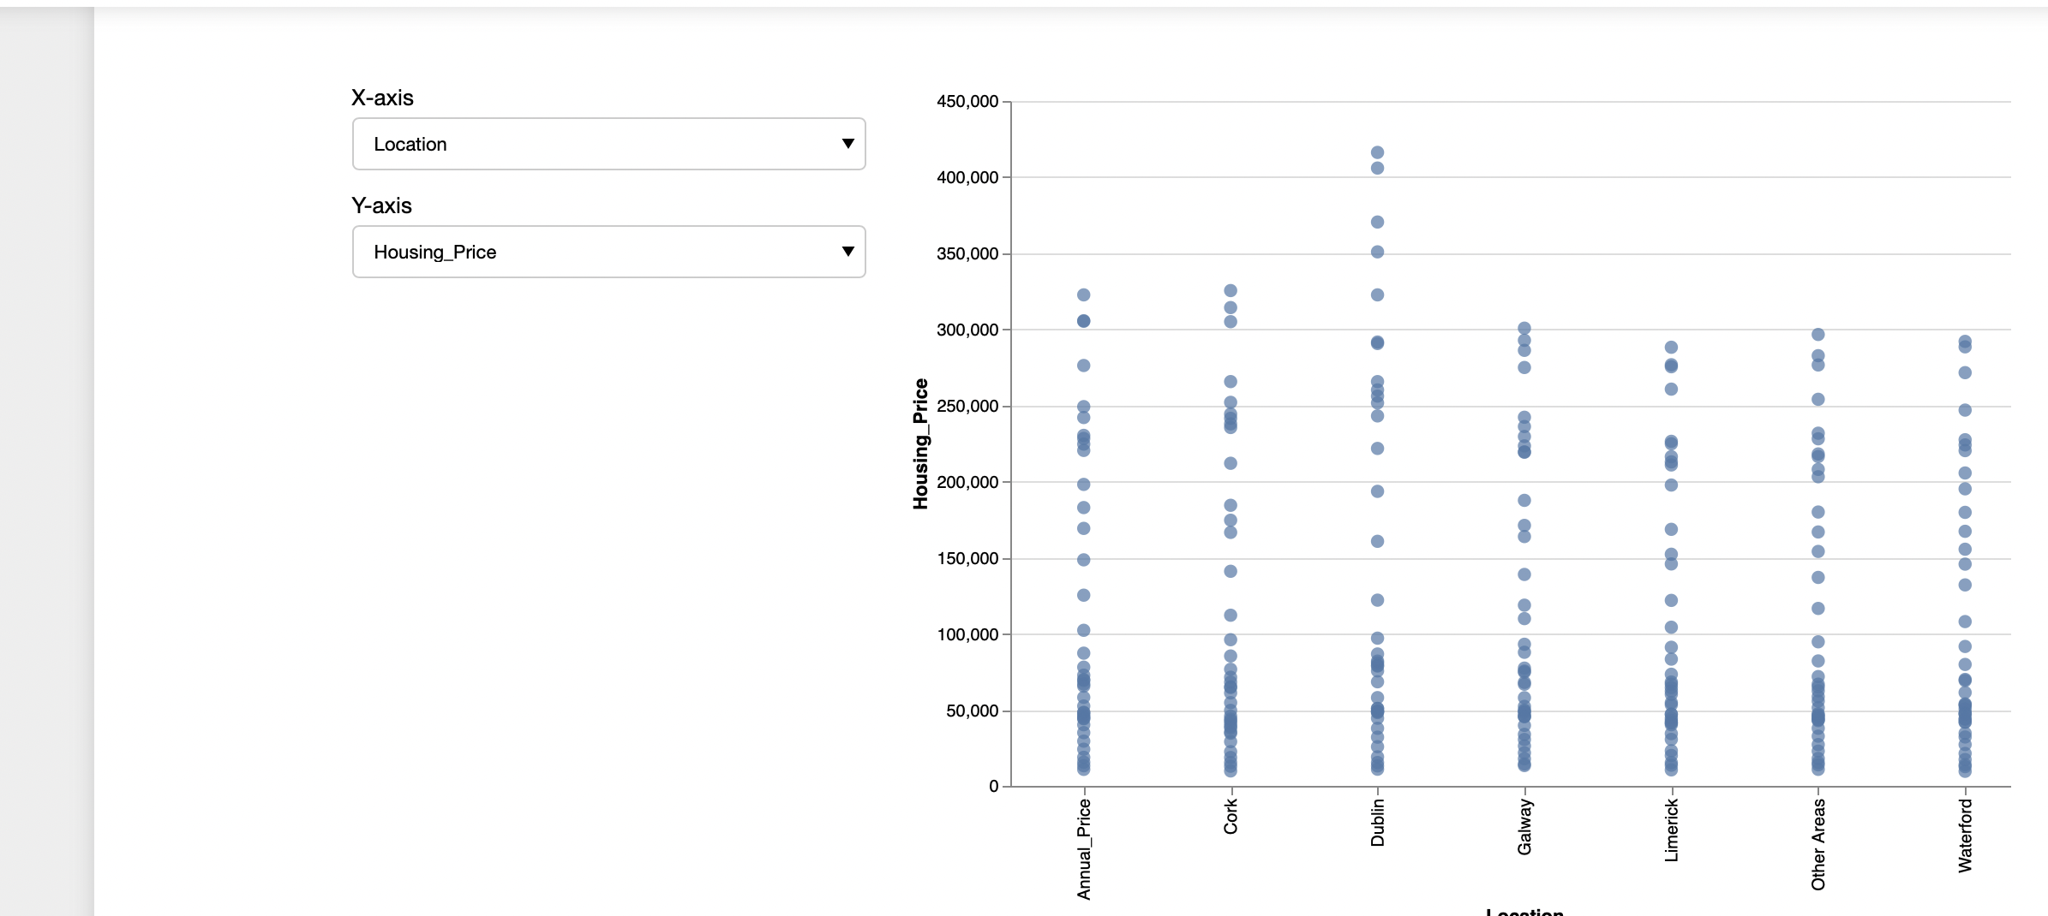

Conclusion:

* Overall we learned to design a Dashboard and create many useful interactive plots which will briefly describe the dataset, its provenance and domain, and a summary of the key insights derived from the exploratory data analysis.

Part3



# References

Abhigyan, 2020. *Medium.* [Online]   
Available at: https://medium.com/analytics-vidhya/importance-of-dimensionality-reduction-d6a4c7289b92  
[Accessed 5 May 2023].

DUTTA, G., 2020. *Kaggle.* [Online]   
Available at: https://www.kaggle.com/datasets/gauravduttakiit/loan-defaulter?select=columns_description.csv  
[Accessed 15 April 2023].